**Black Friday Sales Report**

**Overview**

Between *Nov 1, 2018* and *Dec 31, 2023*, a total of 5,418 records were tracked across 20 locations, featuring 5 unique products from 5 categories. Sales occurred throughout the day, from *00:00:10am to 23:59:47pm*.

**Financial Performance**The sales brought about a total revenue of ₦900,856.59 and an average revenue of ₦166.27 per sale. Data used had an excellent quality of 99.52%.

**Customer Profile**Buyers were profiled with aged people within ages 51years and above making up the highest percentage of buyers (38.76%), Adults between ages 30 and 50 years (38.24%) and Young Adults, less than 30 years (23.00%). They also spent in the order given; ₦353,735.32, ₦336,897.44 and ₦210,223.82 respectively.

**Purchase Timing**The peak sales period was discovered to be the morning (50.28%), then afternoon (20.12%) and evening (17.20%) with the lowest being at night (12.40%).

**Product Performance**Best selling products were discovered to be E*lectronics (1,105 units)*, *Toys (1,097) and Clothing (1,077) with Decorations (1,062) being the lowest. However, Toys brought the highest revenue (₦183,594.22) most likely due to their considerably high prices.*

**City Insights**  
Top Buyers cities were *City_1 & City_13 (both 288 sales)* with the highest revenue coming from *City_1 with ₦49,264.57 which is 5.47% of our revenue.* Other strong contributors were *City_12, City_15, City_17* (5.15 –5.36%)

**Summary**  
The morning period clearly drove bulk sales, especially from Aged and Adult customers. Toys and electronics products dominated revenue generation, while it is notably even among the top five cities. With strong customer retention indicators and clean data, future campaigns could benefit from deeper targeting of high-performing age groups and cities.

**Customer Segment Analysis**

|  |  |  |  |  |  |
| --- | --- | --- | --- | --- | --- |
| **Customer Segments** | **Quantity Bought** | **(₦) Total**  **Spent** | **Average Promo** | **Satisfaction** | **(%) Percentage** |
| **Budget Shoppers** | **25** | **1145.53** | **0.43** | **2.78** | **19.60** |
| **Disloyal Buyers** | **31** | **1748.65** | **0.66** | **2.72** | **23.60** |
| **Heavy**  **Buyers** | **48** | **2637.94** | **0.47** | **2.98** | **25.60** |
| **Light Shoppers** | **26** | **1667.13** | **0.36** | **3.08** | **15.00** |
| **Premium Loyalists** | **29** | **1476.09** | **0.56** | **3.63** | **16.20** |

**Budget Shoppers**This group of buyers spend the least. They buy in moderate quantities but tend to have lower satisfaction. They are cost-conscious and may be influenced by price more than brand loyalty as they always consider their budget more and never buy outside their budget.

**Disloyal Buyers**These buyers use promotions frequently but report the lowest satisfaction levels. Their spending is moderate, and they show limited loyalty to the brand. They may switch brands often based on offers and prices.

**Heavy Buyers**These are the top spenders who purchase the most items overall. Their satisfaction is average, but due to their consistent and high value buying behaviour, make up the major part of the total revenue.

**Light Shoppers**These buyers buy fewer items as they are very sensitive to high prices. They rarely use promotions and have a slightly above-average satisfaction score. Their buying patterns are minimal but reliable**.**

**Premium Loyalists**These customers show strong satisfaction and a steady purchase pattern. They engage moderately with loyalty programs and promotions, suggesting a stable, long-term relationship with the brand.

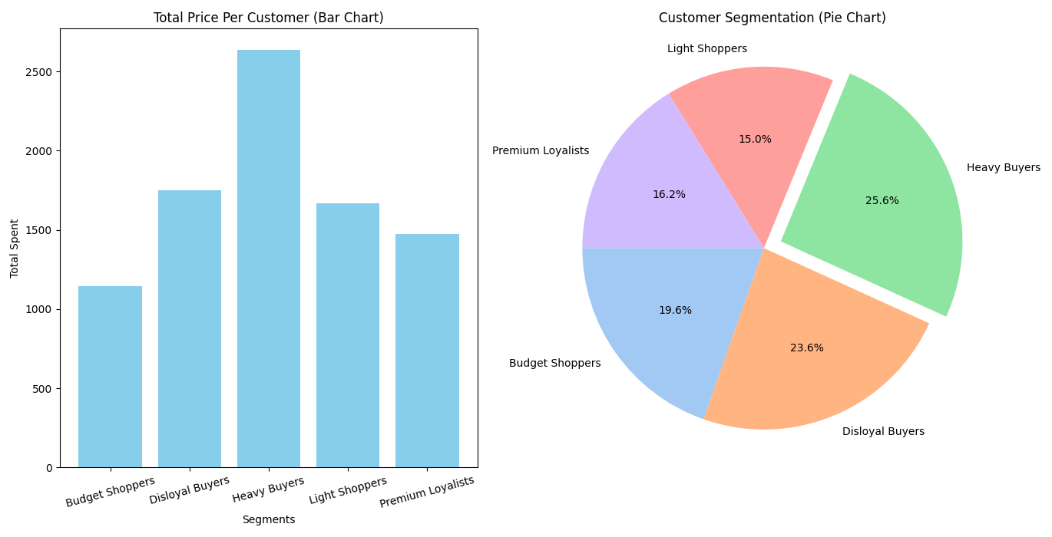

**Targeted Marketing Strategies**

**Budget Shoppers**

* Simple, price-focused promotions like bundle offers and loyalty discounts.
* Make shopping affordable and rewarding to improve satisfaction and retention.

**Disloyal Buyers**

* Personalized follow-up messages
* Limited-time offers to encourage re-engagement.
* Surveys to understand their expectations.

**Heavy Buyers**

* **VIP perks like priority access**
* **Exclusive deals**
* **Premium service.**
* **Feedback opportunities to improve their experience and build a stronger emotional connection.**

**Light Shoppers**

* **Keep things fast, easy, and convenient.**
* **Quick deliver**
* **Simplified checkout and hassle-free navigation to encourage higher purchase frequency.**

**Premium Loyalists**

* **Tailored communications and consistent service quality.**
* **Tiered rewards.**
* **Early or exclusive access to premium products or offers.**

**Product Performance Analysis**

|  |  |  |  |  |
| --- | --- | --- | --- | --- |
| **Category** | **Quantity** | **Satisfaction** | **(₦) Revenue** | **% Revenue** |
| **Toys** | **1097** | **2.98** | **183594.22** | **20.38** |
| **Electronics** | **1105** | **3.00** | **181077.53** | **20.10** |
| **Food** | **1077** | **2.96** | **179952.23** | **19.98** |
| **Clothing** | **1077** | **2.97** | **178172.64** | **19.78** |
| **Decorations** | **1062** | **3.04** | **178059.98** | **19.77** |

**Toys**Toys were the top-earning product, with ₦183,594.22 in revenue from 1,097 units sold. They maintained a solid satisfaction score of 2.98, indicating customer interest and general approval. This category showed strong market demand and high sales volume.

**Electronics**Electronics slightly edged ahead in units sold (1,105), generating ₦181,077.53 in revenue. Customer satisfaction was steady at 3.00, confirming reliability and appeal. While revenue was slightly lower than Toys, this product performed very well overall.

**Food**Food products sold 1,077 units and earned ₦179,952.23 in revenue. Satisfaction was slightly lower at 2.96, which may suggest variability in product quality or packaging. Performance was consistent but showed room for improvement.

**Clothing**Clothing matched Food in unit sales (1,077), generating ₦178,172.64 in revenue. With a satisfaction score of 2.97, it indicates customer response was average. Revenue ranking was low, suggesting limited impact per sale.

**Decorations**Decorations had the fewest units sold (1,062) and the lowest revenue (₦178,059.98). However, it received the highest satisfaction level of 3.04, signalling that customers who did buy were quite pleased. This suggests that visibility and promotion, not product quality, may be the issue.

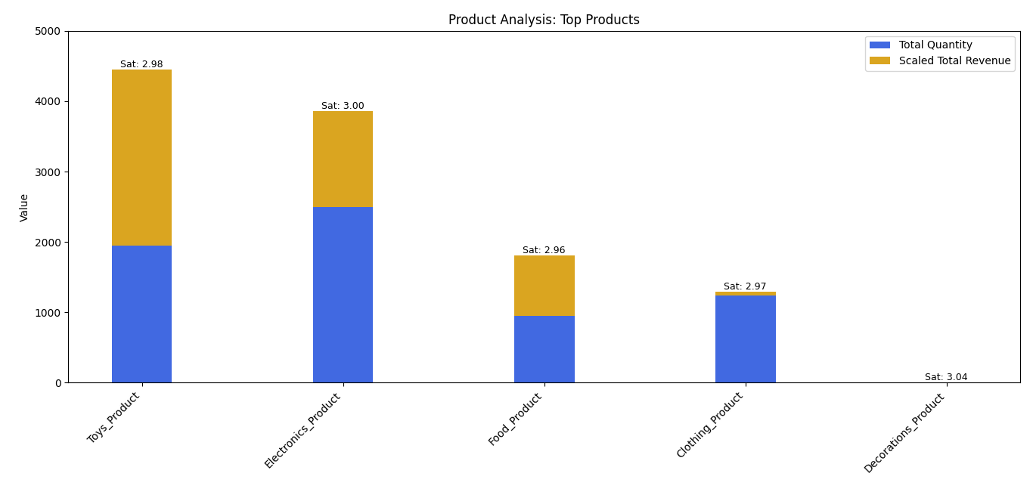

**Discount Strategy Recommendations**

**Toys**Apply a small discount (5–10%). This category is already performing well, so aggressive discounting is unnecessary. Modest incentives or bundle pairings can maintain momentum.

**Electronics**Use a medium discount (10–15%). This strikes a balance between encouraging purchases and protecting margins. Bundling accessories can also improve perceived value.

**Food**Introduce a moderate-to-high discount (15–20%). A price cut may help improve satisfaction and encourage repeat purchases, especially for everyday items**.**

**Clothing**Recommend a high discount (20–25%). Strong markdowns will help reposition this category and improve engagement, especially when paired with seasonal promotions.

**Decorations**Implement a high discount (25–30%). While satisfaction is high, sales are low so the goal is to boost visibility and sales volume quickly.

**Campaign Revenue & ROI**

**Model Performance**

* The prediction model helps estimate how much money the campaign can make.
* **R² Score: 0.48** means the model is fairly accurate. It explains about 48% of the changes in revenue.
* **RMSE: 0.028** tells us the average prediction error is small, so results are dependable.

**Factors That Increase Revenue**

Based on the model:

* **Quantity of items sold** has the biggest effect on revenue (coefficient: 0.40).
* **Discounts** also increase revenue (coefficient: 0.29).
* **Satisfaction**, **weekday**, and **weekend** have little to no impact in this prediction.

So, selling more items and using smart discounts help improve revenue. The other factors are less important for this campaign.

**Expected Results from the Campaign**

* The campaign is expected to raise revenue by **0.03 units**, which leads to an **increase of 9.11%**.
* That means if revenue was $100 before, the campaign could help grow it to around ₦109.11.

**Discount Analysis Overview**

In an attempt to review how different discount levels from 0% to 50% affect key performance areas such as predicted revenue, customer satisfaction, and sales behaviour across weekdays and weekends, the following were discovered.

|  |  |  |  |  |  |  |  |
| --- | --- | --- | --- | --- | --- | --- | --- |
| % Discount | Avg Satisfaction | Weekday Sales Count | Weekday Revenue  (₦) | Weekday Revenue Percentage (%) | Weekend Sales Count | Weekend Revenue  (₦) | Weekend Revenue Percentage  (%) |
| 0 | 0.513 | 25 | 12.36 | -72.59 | 76 | 35.33 | -65.67 |
| 10 | 0.507 | 54 | 20.75 | -53.98 | 125 | 53.22 | -48.29 |
| 20 | 0.502 | 77 | 31.04 | -31.15 | 193 | 80.68 | -21.62 |
| 30 | 0.498 | 111 | 44.60 | -1.06 | 235 | 100.24 | -2.61 |
| 40 | 0.498 | 127 | 54.14 | 20.07 | 273 | 119.83 | 16.42 |
| 50 | 0.496 | 146 | 45.39 | 45.03 | 320 | 146.99 | 42.80 |

This implies:

* Predicted Revenue increases steadily as discounts rise, with the highest revenue observed at 50% discount.
* Customer Satisfaction remains relatively stable across all discount levels, showing that deeper discounts do not negatively affect the shopping experience.
* Weekend Sales consistently outperform Weekday Sales, with weekend revenue averaging 143% higher than weekday revenue.
* The average margin between weekend and weekday revenue is approximately ₦53.71, confirming stronger engagement during weekends.

**Performance by Discount Level**

* **0% Discount:**Revenue and sales are low. Both weekday and weekend performance show large negative percentages. Satisfaction is highest, but overall engagement is weak.
* **10–20% Discount:**Sales volume improves, but revenue and satisfaction slightly decrease. Weekend and weekday performance begin to recover, though still below optimal levels.
* **30% Discount:**Weekend revenue turns positive, and weekday losses reduce significantly. This level marks a turning point where discounts begin to drive net-positive results.
* **40–50% Discount:**Both weekday and weekend sales show strong growth. Revenue is highest, and satisfaction remains consistent. These levels deliver the best overall performance**.** 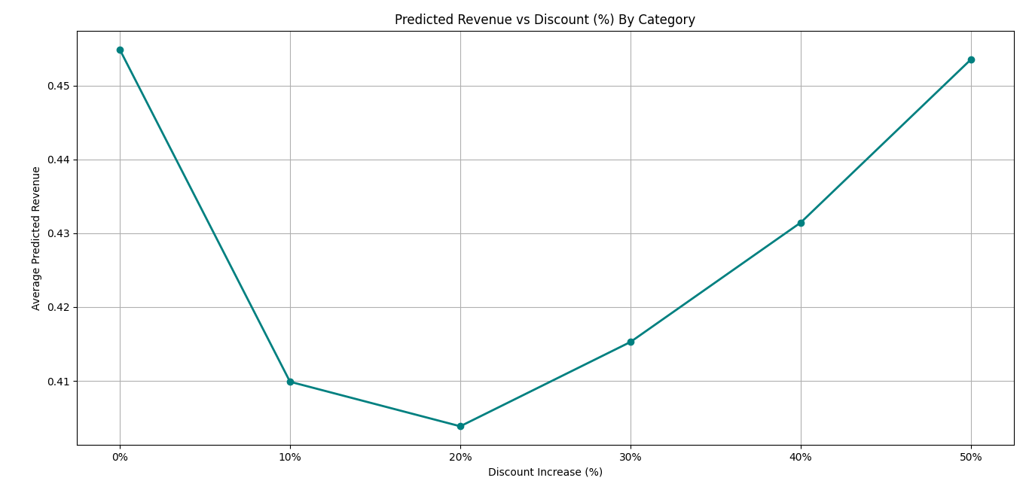

**Conclusion**

* Discounting is effective in increasing revenue and sales volume, especially from 30% upward.
* Weekends respond better to discounts than weekdays, making them ideal for high-impact promotions.
* Customer satisfaction stays stable, even with deeper discounts, which supports more aggressive pricing strategies when needed.

**Recommended Strategy For Black Friday Sales Campaign**

* Focus on increasing quantity, not just satisfaction as volume drives revenue.
* Run timed offers on weekends to boost urgency and engagement.
* Collect feedback to improve offers for Budget and Disloyal buyers.
* Use 15–20% discounts to activate Light Shoppers.
* Give low discounts (5–10%) on bestsellers like Toys and Electronics.
* Offer high discounts (20–30%) on slow-moving items like Decorations.
* Reward loyal customers with exclusive deals and early access
* Focus promotions on weekends to maximize returns as they earn 143% better than weekdays.
* Bundle products to increase quantity sold and total spend especially on weekdays.
* Use 30–40% discounts as a standard for regular campaigns and to grow sales without hurting revenue.
* Reserve 50% discounts for special events or clearance sales.

**Summary**

Retailers looking to boost both sales and revenue during promotional campaigns can benefit from a strategic discounting approach informed by data. The campaign analysis reveals that product performance varies significantly across categories, and discount levels must be tailored accordingly. Toys, which already perform well, require only minimal incentives—small discounts between 5% and 10% or bundled offers are sufficient to maintain momentum. Electronics benefit from moderate discounts of 10% to 15%, striking a balance between attracting buyers and preserving profit margins. Food products, being everyday essentials, respond well to slightly higher discounts in the 15% to 20% range, which can improve satisfaction and repeat purchases. Clothing, which showed weaker performance, requires stronger markdowns of 20% to 25%, especially when paired with seasonal promotions. Decorations, despite high satisfaction, suffer from low sales and should be promoted with aggressive discounts of 25% to 30% to increase visibility and volume.

The campaign’s revenue model supports these strategies. With an R² score of 0.48 and a low RMSE of 0.028, the model reliably predicts revenue outcomes. It identifies quantity sold and discount level as the most influential factors, while satisfaction, weekday, and weekend timing have minimal predictive impact. The model forecasts a revenue increase of 0.03 units, or 9.11%, confirming that smart discounting and volume growth are key drivers of success.

Further analysis of discount levels from 0% to 50% shows a clear upward trend in predicted revenue. Customer satisfaction remains stable across all levels, indicating that deeper discounts do not harm the shopping experience. Weekend sales consistently outperform weekday sales, with weekend revenue averaging 143% higher. The average margin between weekend and weekday revenue is ₦53.71, highlighting stronger customer engagement during weekends.

Performance improves notably at 30% discount, where weekend revenue turns positive and weekday losses shrink. At 40% and 50%, both weekday and weekend sales show strong growth, and overall campaign performance peaks. These findings support the conclusion that discounting is most effective from 30% upward, with weekends offering the best opportunity for high-impact promotions. Retailers are encouraged to adopt aggressive pricing strategies where needed, without compromising customer satisfaction.